**UET Quiz Mobile App**



**Session 2023 - 2027**

**Submitted by:**

Amir Hashmi 2023-CS-11

**Supervised by:**

Prof. Khaldoon Khurshid

**Course:**

Advanced Database

Department of Computer Science

### **University of Engineering and Technology Lahore Pakistan**

### ****1. Introduction****

The UET Quiz Mobile App is a cross-platform application developed using React Native and Expo, designed to facilitate quiz creation for teachers and quiz attempts for students. The app supports **offline functionality** through SQLite, ensuring data persistence even without internet connectivity.

### ****2. Features****

**2.1 Teacher Features**

* Create, edit, and delete quizzes.
* Add multiple-choice questions with customizable options.
* Publish/unpublish quizzes for student access.
* View student performance analytics.

**2.2 Student Features**

* Attempt quizzes offline.
* Receive instant results with score breakdowns.
* Review past quiz attempts and performance history.

### ****3. Technical Specifications****

**3.1 Tech Stack**

* **Frontend**: React Native + Expo.
* **Database**: SQLite (local storage)(In-memory).
* **State Management**: Context API.
* **Navigation**: React Navigation.

**3.2 Database Schema**

The SQLite database includes the following tables:

* **Users**: Stores teacher/student credentials.
* **Quizzes**: Contains quiz metadata (title, publish status).
* **Questions**: Links to quizzes with question text.
* **Answers**: Stores options and correct answers.
* **Results**: Tracks student attempts and scores..

### ****4. Offline Functionality****

* All data is stored locally via SQLite.
* Teachers can draft quizzes offline; changes sync when online.
* Students can attempt quizzes without internet access.

### ****Wireframes****

****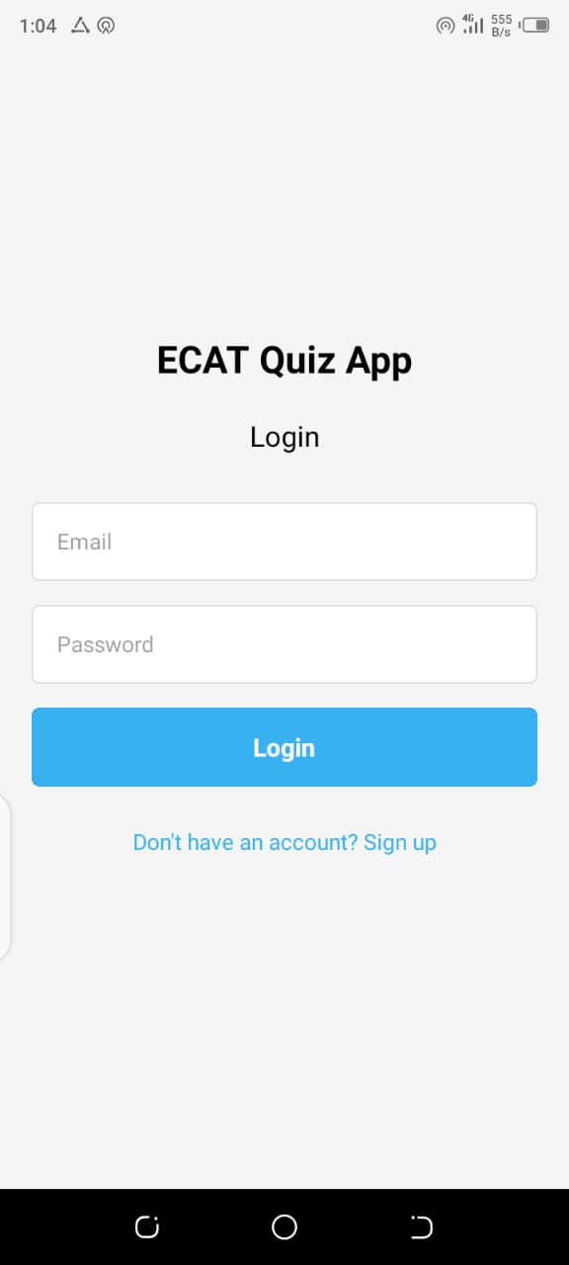 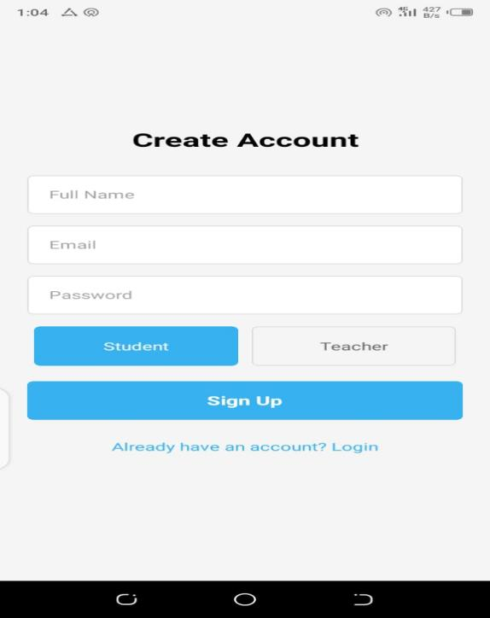****

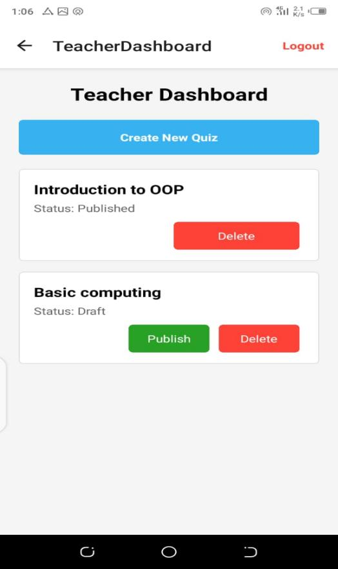 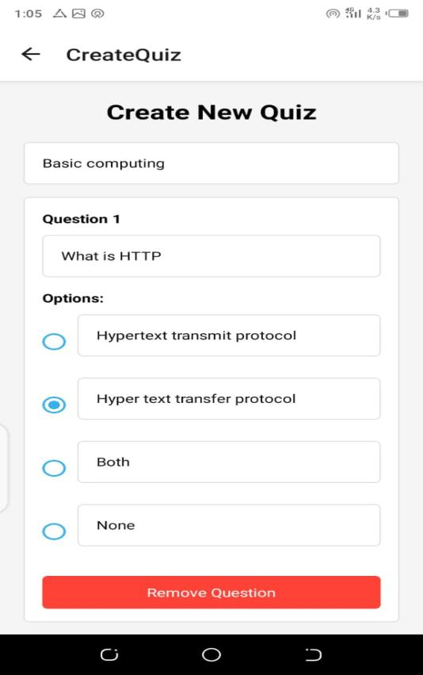

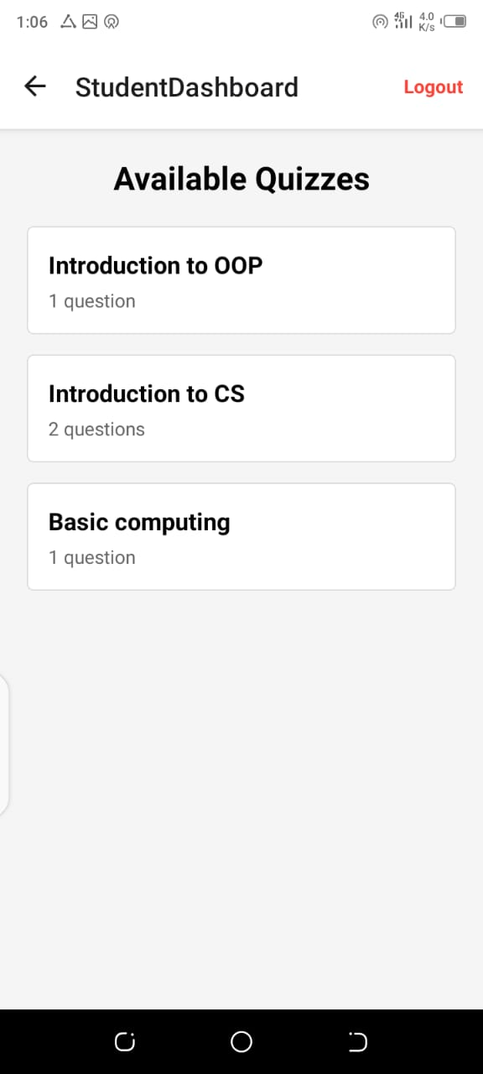 ****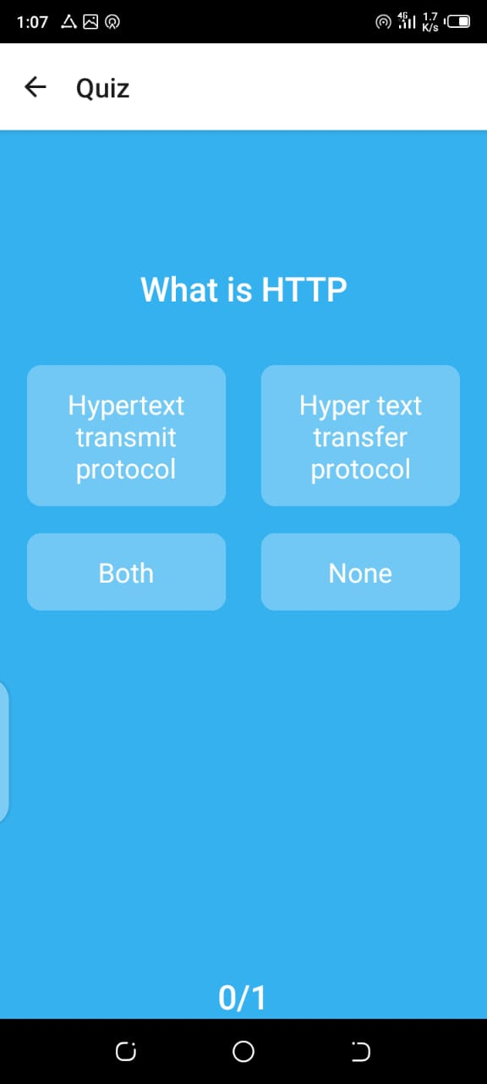****

****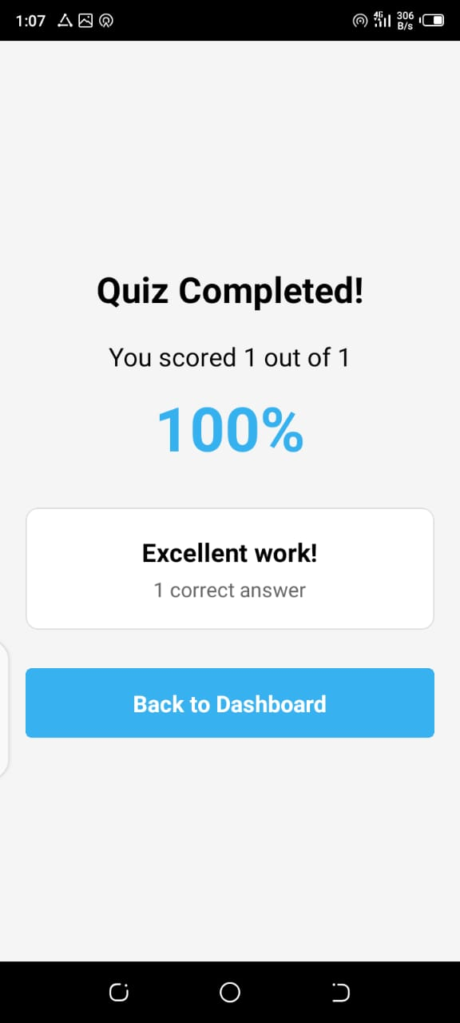****

### ****6. Conclusion****

The UET Quiz Mobile App demonstrates the use of **React Native for cross-platform development** and **SQLite for offline data persistence**, making it ideal for educational environments with limited connectivity.

**GitHub Repository:**   
<https://github.com/AmirHashmi017/Mobile-App-Development/tree/main/quiz-app>